emissions_by_country

William F. Lamb

17 11 2020

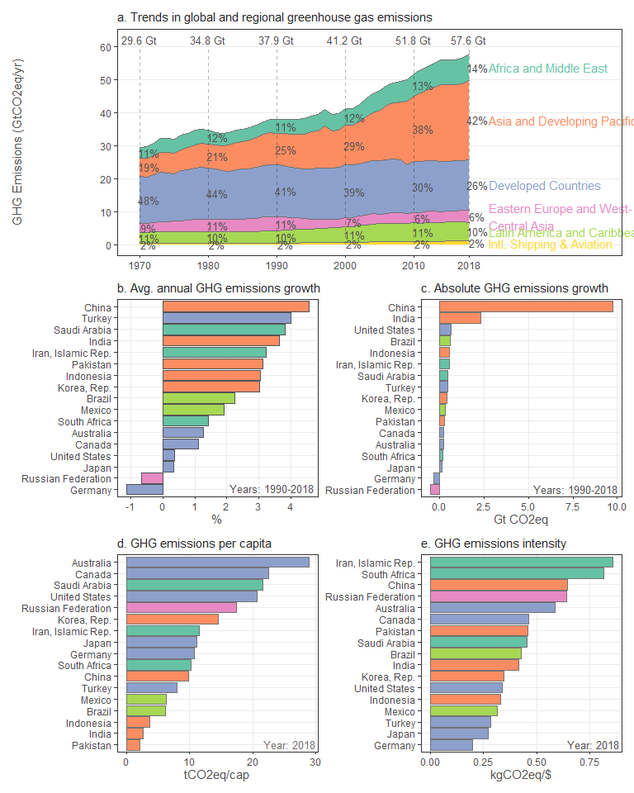

#```{r per_capita_by_region,echo=FALSE,warning=FALSE}

per_capita <- edgar_GHG_ar6 %>% group_by(country,ISO,year,region_ar6_5) %>% summarise(CO2=sum(CO2,na.rm=TRUE),GHG=sum(GHG,na.rm=TRUE)) %>% ungroup()

per_capita <- left_join(per_capita,basic %>% select(Year,ISO,pop_UN),by=c(“year”=“Year”,“ISO”=“ISO”))

per_capita <- per_capita %>% filter(year==2018) %>% mutate(CO2_pc = CO2/pop_UN) %>% mutate(GHG_pc = GHG/pop_UN)

all_countries <- per_capita

### remove intl. shipping, aviation and countries at zero emissions and small countries

per_capita <- per_capita %>% filter(region_ar6_5!=“Intl. Aviation”) %>% filter(region_ar6_5!=“Intl. Shipping”) %>% filter(CO2_pc>0) %>% filter(pop_UN>1e6)

per_capita <- per_capita %>% group_by(region_ar6_5) %>% summarise(GHG_pc_max=max(GHG_pc,na.rm=T),GHG_pc_min=min(GHG_pc,na.rm=T))

region_averages <- all_countries %>% filter(region_ar6_5!=“Intl. Aviation”) %>% filter(region_ar6_5!=“Intl. Shipping”) %>% group_by(region_ar6_5) %>% summarise_at(vars(CO2,GHG,pop_UN),sum,na.rm=TRUE)

per_capita <- left_join(per_capita,region_averages,by = “region_ar6_5”)

per_capita <- per_capita %>% mutate(GHG_mean = GHG/pop_UN) %>% mutate(CO2_mean = CO2/pop_UN)

#```{r cumulative_emissions_income,echo=FALSE,warning=FALSE}  
  
cumulative_emissions_income <- edgar_GHG_ar6 %>%   
 group_by(country,ISO,year,region_ar6_dev) %>%   
 summarise(CO2=sum(CO2,na.rm=TRUE),GHG=sum(GHG,na.rm=TRUE)) %>%   
 ungroup()  
  
cumulative_1990 <- cumulative_emissions_income %>%   
 filter(year>1989) %>%   
 group_by(region_ar6_dev) %>%   
 summarise(GHG_since_1990=sum(GHG/1e9))  
  
cumulative_2010 <- cumulative_emissions_income %>%   
 filter(year>2009) %>%   
 group_by(region_ar6_dev) %>%   
 summarise(GHG_since_2010=sum(GHG/1e9))  
  
cumulative_emissions_income <- left_join(cumulative_1990,cumulative_2010)  
  
total_2010 <- sum(cumulative_emissions_income$GHG_since_2010)   
total_1990 <- sum(cumulative_emissions_income$GHG_since_1990)  
  
cumulative_emissions_income <- cumulative_emissions_income %>%   
 mutate(fraction_since_1990=GHG_since_1990/total_1990) %>%   
 mutate(fraction_since_2010=GHG_since_2010/total_2010)

#```{r cumulative_emissions_geo,echo=FALSE,warning=FALSE}

cumulative_emissions_geo <- edgar_GHG_ar6 %>% group_by(country,ISO,year,region_ar6_5) %>% summarise(CO2=sum(CO2,na.rm=TRUE),GHG=sum(GHG,na.rm=TRUE)) %>% ungroup()

cumulative_1990 <- cumulative_emissions_geo %>% filter(year>1989) %>% group_by(region_ar6_5) %>% summarise(GHG_since_1990=sum(GHG/1e9))

cumulative_2010 <- cumulative_emissions_geo %>% filter(year>2009) %>% group_by(region_ar6_5) %>% summarise(GHG_since_2010=sum(GHG/1e9))

cumulative_emissions_geo <- left_join(cumulative_1990,cumulative_2010)

total_2010 <- sum(cumulative_emissions_geo $GHG_{s}ince_{2010})total_{1990}<−sum(cumulative_{e}missions_{g}eo$ GHG_since_1990)

cumulative_emissions_geo <- cumulative_emissions_geo %>% mutate(fraction_since_1990=GHG_since_1990/total_1990) %>% mutate(fraction_since_2010=GHG_since_2010/total_2010)

#```{r region_comparison,echo=FALSE,warning=FALSE}  
  
# blarg <- edgar_GHG_ar6 %>%  
# filter(year==2018) %>%   
# group_by(region_ar6_dev) %>%   
# summarise(GHG=sum(GHG,na.rm=T)/1e9)  
#   
# blarg2 <- edgar_GHG_ar6 %>%  
# filter(year==2018) %>%   
# group_by(region_ar6_5) %>%   
# summarise(GHG=sum(GHG,na.rm=T)/1e9)  
#   
#   
# regions <- edgar_GHG_ar6 %>%   
# filter(year==2018) %>%  
# group_by(country,ISO,year,region_ar6_dev,region_ar6_5) %>%   
# summarise(GHG=sum(GHG,na.rm=T))  
#   
# regions <- left_join(regions,basic %>% select(Year,ISO,pop_UN),by=c("year"="Year","ISO"="ISO"))  
#   
#   
# regions <- regions %>%   
# filter(region_ar6_5=="Developed countries" | region_ar6_dev=="developed")

#```{r ridgeline_plot,echo=FALSE,warning=FALSE,fig.width=9,fig.height=5}

load(‘../../Data/basic.RData’)

## get country level data

countries <- edgar_GHG_ar6 %>% filter(region_ar6_5_short!=“AIR”) %>% filter(region_ar6_5_short!=“SEA”) %>% group_by(country,ISO,year,region_ar6_5_short,region_ar6_10) %>% summarise(GHG=sum(GHG,na.rm=TRUE))

### join pop and gdp

basic <- basic %>%  
select(ISO,Year,pop_UN)

countries <- left_join(countries,basic,by=c(“ISO”=“ISO”,“year”=“Year”))

### select two time frames

countries_tf1 <- countries %>% filter(year>=1990 & year<2000) %>% group_by(country,ISO,region_ar6_5_short,region_ar6_10) %>% summarise(GHG=sum(GHG)/10,pop_UN=sum(pop_UN)/10) %>% mutate(year=‘1990_1999’)

countries_tf2 <- countries %>% filter(year>=2010 & year<2019) %>% group_by(country,ISO,region_ar6_5_short,region_ar6_10) %>% summarise(GHG=sum(GHG)/10,pop_UN=sum(pop_UN)/10) %>% mutate(year=‘2000_2018’)

countries <- rbind(countries_tf1,countries_tf2)

countries <- countries %>% mutate(emissions_pc=GHG/pop_UN)

library(ggridges)

countries %>% ggplot(.,aes(x=emissions_pc,y=region_ar6_10,fill=year)) + geom_density_ridges() + xlim(-10,100)

countries %>% ggplot(.,aes(x=emissions_pc,y=region_ar6_10,fill=year)) + geom_boxplot() + xlim(-10,100)

#```{r save, echo=FALSE, warning=FALSE}  
  
#   
# openxlsx::addWorksheet(wb,"country_emissions_2018")  
# openxlsx::writeData(wb,"country_emissions_2018",all_countries, colNames = T, rowNames = F)  
  
openxlsx::addWorksheet(wb,"region_summary_2018")  
openxlsx::writeData(wb,"region_summary_2018",per_capita, colNames = T, rowNames = F)  
  
openxlsx::addWorksheet(wb,"cumulative_GHG_emissions_income")  
openxlsx::writeData(wb,"cumulative_GHG_emissions_income",cumulative_emissions_income, colNames = T, rowNames = F)  
  
openxlsx::addWorksheet(wb,"cumulative_GHG_emissions_geo")  
openxlsx::writeData(wb,"cumulative_GHG_emissions_geo",cumulative_emissions_geo, colNames = T, rowNames = F)  
  
# openxlsx::addWorksheet(wb,"region_comparison")  
# openxlsx::writeData(wb,"region_comparison",regions, colNames = T, rowNames = F)  
  
  
openxlsx::saveWorkbook(wb,paste0("../../Results/Data/ipcc_ar6_data_regions_countries",".xlsx"),overwrite=T)

#```{r old, echo=FALSE, warning=FALSE}

side figures - per capita and per gdp

# load(‘../Data/basic.RData’)

# load(‘../Data/tsu_codes.RData’)

# basic <- basic %>%

# filter(Year>=1990 & Year<2019) %>%

# select(ISO,Year,pop_UN,gdp_ppp_WB) %>%

# filter(ISO!=“WLD”)

# basic <- left_join(basic,tsu_codes %>% select(ISO,region_ar6_5))

# basic <- basic %>%

# group_by(Year,region_ar6_5) %>%

# summarise_at(vars(gdp_ppp_WB,pop_UN),sum,na.rm=T)

# side_plot_data <- edgar_GHG_ar6 %>%

# filter(year>1989) %>%

# filter(year<2019) %>%

# filter(region_ar6_5!=“Intl. Aviation”) %>%

# filter(region_ar6_5!=“Intl. Shipping”) %>%

# group_by(year,region_ar6_5,region_ar6_5_short) %>%

# summarise_at(vars(GHG),sum,na.rm=TRUE)

# side_plot_data <- left_join(side_plot_data,basic,by=c(“year”=“Year”,“region_ar6_5”=“region_ar6_5”))

# side_plot_data <- side_plot_data %>%

# mutate(GHG_pc = GHG/pop_UN) %>%

# mutate(GHG_pgdp = GHG/gdp_ppp_WB*1000) %>%

# mutate(GHG_pgdp = ifelse(year==2018,NA,GHG_pgdp))

# p2_1 <- side_plot_data %>%

# ggplot(.,aes(x=year,y=GHG_pc,colour=region_ar6_5_short)) +

# geom_line() +

# theme_bw() +

# ylab(‘GHG Emissions(tCO2eq/cap)’) +

# theme(legend.position = “none”,

# axis.title.x = element_blank(),

# text = element_text(size=11),

# panel.grid.minor.x = element_blank(),

# panel.grid.minor.y = element_blank())

# p2_2 <- side_plot_data %>%

# ggplot(.,aes(x=year,y=GHG_pgdp,colour=region_ar6_5_short)) +

# geom_line() +

# theme_bw() +

# ylab(‘GHG Emissions intensity(gCO2eq/$)’) +

# theme(legend.position = “bottom”,

# axis.title.x = element_blank(),

# text = element_text(size=11),

# panel.grid.minor.x = element_blank(),

# panel.grid.minor.y = element_blank())

# p2 <- ggarrange(p2_1,p2_2,ncol=1,nrow=2)

```